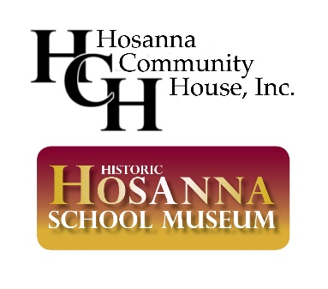
2021 JUNETEENTH CELEBRATION FESTIVAL
Saturday, June 19, 2021 from 6 pm to 8 pm EST

FOOD AND CRAFT VENDOR APPLICATION

DATE:_______________________

The completed contract with payment is due by May 15, 2021.

YOUR NAME:____________________________ BUSINESS NAME:__________________________

BUSINESS ADDRESS:_______________________________________________________________

BUSINESS PHONE:_________________________ YOUR CELL PHONE:_____________________

EMAIL:___________________________________________________________________________

WEBSITE or FACEBOOK PAGE (if available): ___________________________________________

TYPE(S) OF FOOD OR CRAFT :______________________________________________________

Food and Craft Vendor Terms & Conditions: Options for participation in Vendor Fair (please check one):

_______ OPTION 1: Pay a fee of $50 to be included in the Juneteenth Celebration Booklet
featuring local Black-owned businesses, and attend the vendor fairs during the virtual
2021 Juneteenth Celebration to answer questions about your merchandise from
program attendees.

OR

_______ OPTION 2: Pay a fee of $100 to be included in the Juneteenth Celebration Booklet
featuring local Black-owned businesses, send a your organization’s 30-second video of
your merchandise/organization to be shown during the virtual vendor exhibition, and
attend the vendor fairs during the virtual 2021 Juneteenth Celebration to answer
questions about your merchandise from program attendees.

All vendors will need to provide their logo (color jpeg at least 300 dpi) and a brief one-line description of their business no later than May 15th. If you choose OPTION 2 and would like to be included in the virtual vendor exhibition, please submit a 30-second video that highlights your organization/merchandise to Patricia Cole at juneteenth@hosannaschoolmuseum.org by
May 15th.
Suggested Juneteenth Discount
We are asking all vendors to consider offering a discount during the week leading up to (June 13–18) or after (June 19–26) Juneteenth for registered attendees. This will be a great way to promote your organization leading up to the virtual Juneteenth Celebration and incentivize attendees to support you. We will follow up with you individually about your discount, which can be advertised in the Juneteenth Celebration Booklet.

Payment Information
Electronic Payment Options:
- Submit PayPal or Credit Card payment at www.hosannaschoolmuseum.org/donate/
- Send payment via CashApp at $1867Hosanna

If paying by check, make checks payable to Hosanna Community House, Inc. and mail to our treasurer, James Thornton (James Thornton, Treasurer, Hosanna Community House, Inc. P.O. Box 305 Darlington, MD 21034). For payment questions, you can contact James Thornton at jthorn2@aol.com.

Liability Waiver
As a food or craft vendor, I hereby release the Hosanna Community House, Inc., doing business as Hosanna School Museum, and all those who assist in the Juneteenth Celebration to be held on Saturday, June 19, 2021 from any and all liability for any damage, injury, or loss of any person or property, from any cause whatsoever arising out of or in any way connected with the aforesaid Celebration.

Signature Date

My signature indicates understanding and compliance with the above statements.

