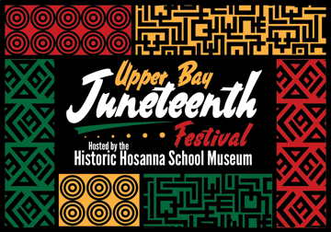
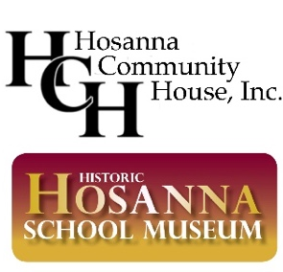

2022 Upper Bay JUNETEENTH Festival
Organization/Corporate Sponsor Form

We, ___________________________, embrace the opportunity to enhance the
understanding of and appreciation for the rich cultural history of Harford County
through the lens of the African American experience. We choose to:

______ be a BENEFACTOR with a contribution of $2,500 - $5,000
(Benefits: company logo on commemorative Juneteenth program banner and emails advertising event; 7 ½ W x 4 ½ H ad in Juneteenth celebration booklet; and contribution noted on website; Four event entry tickets)

______ be a FRIEND with a contribution of $1,000 - $2,499
(Benefits: company logo on commemorative Juneteenth program banner and emails advertising event, contribution noted on the website and listed in Juneteenth celebration booklet; Two event entry tickets)

______ be an ASSOCIATE with a contribution of $500 - $999
(Benefits: company name listed on emails advertising event, contribution noted in program booklet and website)

______ be a SUPPORTER with a contribution of $250 - $499
(Benefits: contribution noted in program booklet and website)

_______________________________________________________________________

ORGANIZATION/COMPANY NAME
(Please provide title as preferred for publicity purposes)

_______________________________________________________________________
ADDRESS

CONTACT PERSON TELEPHONE NUMBER

The Board of Directors and Friends of Hosanna Community House Inc., doing business as Hosanna School Museum, thank you for helping us make Harford County an even better place to live, work, and raise our children by preserving and sharing the rich cultural history of Hosanna School Museum and McComas Institute.

Electronic Payment Options:
- Submit PayPal or Credit Card payment at www.hosannaschoolmuseum.org/donations/
- Send payment via CashApp at $1867Hosanna

If paying by check, make checks payable to Hosanna Community House, Inc. and mail to our treasurer, James Thornton.

James Thornton, Treasurer Direct questions to:
Hosanna Community House, Inc. Michael Glass, Event Sponsorship Chair
P.O. Box 305 Darlington, MD 21034 410-802-0008
Jim.Thornton@hosannaschoolmuseum.org Michael.Glass@hosannaschoolmuseum.org

