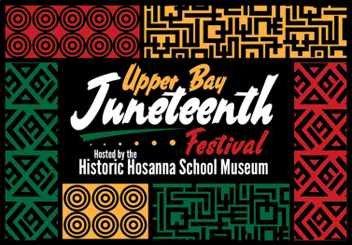
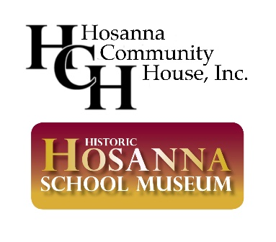

Dear Potential Sponsor,

The Board of Directors of Hosanna Community House, Inc., doing business as Hosanna School Museum, is sponsoring our seventh annual Juneteenth Celebration, renamed the “Upper Bay Juneteenth Festival” hosted by the historic Hosanna School Museum. The new name represents the broad reach and the collaborative community effort required to make it a success.

Juneteenth commemorates the end of slavery in the US and celebrates African American contributions, leadership, artistry, and innovation.

We will host our in-person celebration on Saturday, June 17, 2023, from 12-6 pm. We will feature various presentations, food and craft vendors, Buffalo Soldiers, horse rides, book signings, a puppet show, and more. It’s an afternoon of “edu-tainment” for the whole family! Since our first year, our in-person attendance nearly doubled from the previous year to more than 2,200 visitors by the third year! While the pandemic had caused us to celebrate virtually for two years, we anticipate a resurgence this year, particularly since Juneteenth is now a national holiday.

We are seeking corporate sponsors looking for an opportunity to reach out to the community and support a worthwhile cause through a donation and/or with volunteers. Your support helps preserve our historic sites, the critical history associated with them, and the rich history and culture of Harford County.

Hosanna School was the first of the four Freedmen’s Bureau schoolhouses in Harford County, MD. Built in 1867, community leaders established it while the end of the Civil War still raged and it became the center of the African American community until it closed in 1946. It is on the National Register of Historic Places.

I have enclosed a donor form for your convenience with sponsorship levels. With your contribution, we will note your sponsorship in our publicity. Please respond by May 15, 2023.

If you need more information, contact admin@hosannaschoolmuseum.org or (410) 457-4161 or contact me directly at donnaelewis54@gmail.com or (410) 802-0008.

Sincerely,

Donna E. Lewis
Event Sponsorship Chair

